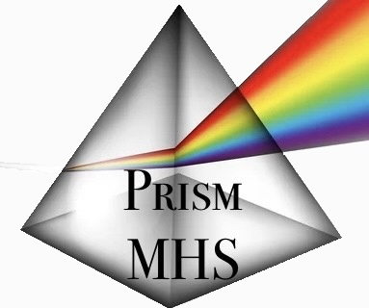
Prism Mental Health Solutions
264 Haida Ave, Ste B1
Hastings, PA 16646
(814) 931 – 0417

Informed Consent Document
I consent to participate in the necessary therapy or other procedures during assessment and treatment with
Prism Mental Health Solutions.

I understand that my clinician is a mandated reporter and is required by law to report to the appropriate authority information about suspected abuse or neglect of a child, an incompetent or disabled person, or an elderly person. If you reveal information that indicates a clear threat of harm to yourself or others the clinician will need to contact appropriate authorities, warn the potential victim, or take other reasonable action to prevent harm from occurring.

I understand that certain mental health disorders can have medical or biological origins, and in such cases, I should consult with a physician.

I understand that all files are kept confidential. My written consent is required for any release of information by
Prism Mental Health Solutions or the clinician listed above to other persons, organizations, or agencies except in the rare cases of court orders, child abuse, life-threatening situations, and national security issues.

I am aware that I have the right to discontinue at any time, except in case where the treatment or assessment has been ordered by the court. My therapist may discontinue treatment if it becomes reasonably clear that I am not benefiting from treatment.

I am aware that the practice of psychotherapy and related disciplines is not an exact science, and I acknowledge that no guarantees have been made to me because of therapy, assessment, or consultation.

I agree to use the video-conferencing platform selected for our virtual sessions. I understand confidentiality still applies for telemental health services, and nobody will record the session without my permission. I understand I need a webcam or smartphone during telehealth sessions. It is important to be in a quiet, private space that is free of distractions (including cell phone or other devices) during the session. It is important to use a secure internet connection rather than public/free Wi-Fi. It is important to be on time. If you need to cancel or change your tele-appointment, you must notify Prism Mental Health Solutions in advance by phone or email to avoid cancellation fees. We need a back-up plan (e.g., phone number where you can be reached) to restart the session or to reschedule it, in the event of technical problems. As your telemental health provider, I may determine that due to certain circumstances, telepsychology is no longer appropriate and that we should make other arrangements.

Your signature below means that a) you have read this document and have been given an opportunity to ask questions; and b) you understand and accept the conditions of this Informed Consent document.

___________________________________________________ ___________________
Client Date

___________________________________________________ ___________________
Representative of Prism Mental Health Solutions Date

