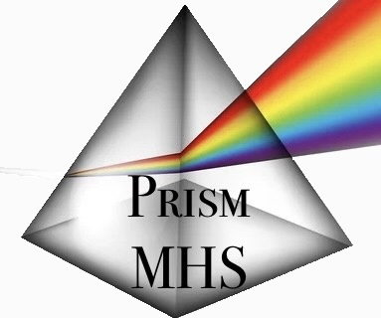
Prism Mental Health Solutions
264 Haida Ave, Ste B1
Hastings, PA 16646
(814) 931 – 0417

Business Policies
Confidentiality: All identifiable information is kept confidential unless you sign a release of information.
Limits to confidentiality:
- We are mandated by law to disclose information if we believe you may be a danger to yourself or to another person or their property.
- We are mandated by law to disclose information about suspected child or elder abuse.
Sessions: Couples’ sessions are 60 minutes in length with a session rate of $175. Individual sessions range from 30 minutes to 60 minutes in length with a session rate of $80 to $150. Usual and consistent sessions provide the most effective therapeutic benefit, however, session frequency will be agreed upon when developing treatment goals.
Cancellations/No Shows: If you need to cancel or reschedule an appointment, you must give 24-hours notice. If less than 24-hour notice is given or you are a no show, you will be charged for the time reserved for you. If you are more than 15 minutes late for a scheduled appointment, then Prism Mental Health Solutions reserves the right to cancel the appointment. Please understand that should you arrive late, we may not be able to extend the session to accommodate for the time missed.
Payment: Payment is due at the time of the service. We are presently working with insurance companies to cover your services. Please understand that we cannot currently accept all insurances. Please inquire prior to scheduling an appointment so you are not billed for services that you were not expecting. We are working to credential with as many insurance companies as possible to provide the best treatment options.
Phone consultations: If you find it necessary, and our schedules permit, we are available for phone consultations at the usual hourly rate in 15-minute increments.
We can be reached through our cell phones Monday through Friday during regular business hours. During nights and weekends, we are available according to arranged times that must be discussed in advance. If you reach our voicemail, please leave a clear message including your name, phone number, and the best time to return your call. Each therapist will provide specific contact information during your first session.
Please read carefully and discuss any questions you may have with us prior to signing. Your signature indicates you understand and accept these policies.
Client Signature: ____________________________________________ Date: _______________

Representative of Prism MHS: _____________________________ Date: _______________

